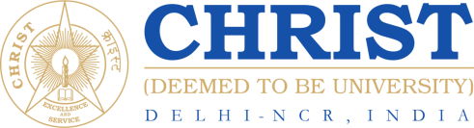
- Languages – JavaScript, PHP, reactJS, nextJS, C, C++, NodeJS
- Database - MongoDB, MySQL, firebase
- Development tools - MS office, Canva, vscode, GitHub, AWS
- Leadership Skills
- Management skills
- Problem-solving
- Time management

- Summer Internship
- Organisation: BillClap IIM Lucknow
Duration: 2 months
Role: Full stack Software Developer
May 2025 – July 2025

- Organisation: Sainsankalpam Bangalore
Duration: 6 months
Role: Web Developer & IT Support
May 2025 – July 2025

Key Skills
Internship & Projects
- Artificial intelligence – Intel Unnati program
- Project 1 – Bharat Drive App
- Project 2 – CrowdFunding Donation Website
- Project 3 – Face recognition Attendance system

Additional Certification & Projects
Results-driven React Developer with a strong foundation in frontend development, modern web technologies, and state management. Currently pursuing a Master’s in Computer Applications at Christ University, with hands-on experience in React.js, Redux, TypeScript, Tailwind CSS, Firebase, and Node.js. Passionate about building efficient, scalable, and high-performance web applications, with a keen focus on code quality, performance optimization, and seamless API integration. A quick learner with strong problem-solving abilities, eager to contribute to innovative projects in a dynamic environment.
Contact no: 9667580993
Email Id: itmealanbiju@gmail.com
Alan Biju
Educational Background
- MCA: (Christ University Delhi NCR) (2024-2026) - 73.4%.
- BCA: (Guru Gobind Singh Indraprastha University , Delhi ) (2021-2024) – 81%
- KG - XII: (St Mary’s Sr Sec School, Delhi) (C.B.S.E board – 2008 -2021) - 78%. in 12th

E-mail: abc@christuniversity.in
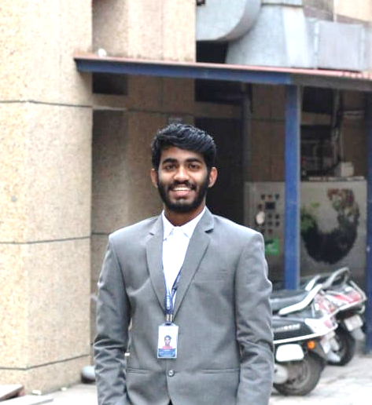
- Date of Birth: 01/12/2003
- Nationality: Indian
- Language Proficiency:
Malayalam - Native
Hindi - Professional
English – Professional
- Mobility: Willing to relocate anywhere in India and Overseas.

- Participated in Inter School Badminton Competition.
- Research Paper on forex currency forecasting using ensemble machine learning models.
- Participated in Multiple IEEE and Springer Conferences

Personal Information
Notable Accomplishment

